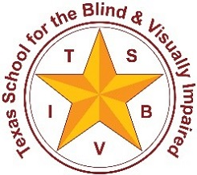
Texas School for the Blind & Visually Impaired
Outreach Programs
www.tsbvi.edu | 512-545-8631 | 1100 W. 45th St. | Austin, TX 78756

Assessment Matrix for Students who are Deafblind

Communication and Emerging Language:
- Communication Matrix
- Home Talk
- Lilly Neilson’s - Functional Scheme Assessment
- Van Dijk – Child guided assessment
- Sensory Learning Kit (SLK)
- Infused Skills Assessment (ISA)
- Every Move Counts
- INSITE – Early Childhood
- Multiple Sensory Impairment (MSI)

Vision:
- ADAMLS
- Evals – pre-braille Compensatory/Access skills checklist
- CVI checklist

Hearing:
- IFHE – Informal Functional Hearing Evaluation
- FAPI
- COW
- Dial
- ELF

ECC:
- Independent Living skills checklist
- TAPS
- TSBVI Performance Indicators

PGC:
- Requisite Concept Eval (RCE)
- Performance Indicators

Programming Assessment:
- IEP Quality Indicators
- Classroom Observation Tool
- Determining the Need for an Intervener

