Texas School for the Blind and Visually Impaired
Outreach Programs
www.tsbvi.edu | 512-454-8631 | 1100 W. 45th St. | Austin, TX 78756

Kersten’s Calendar in Deanna’s Class

Deanna Peterson, Deafblind Specialist, Texas Deafblind Outreach
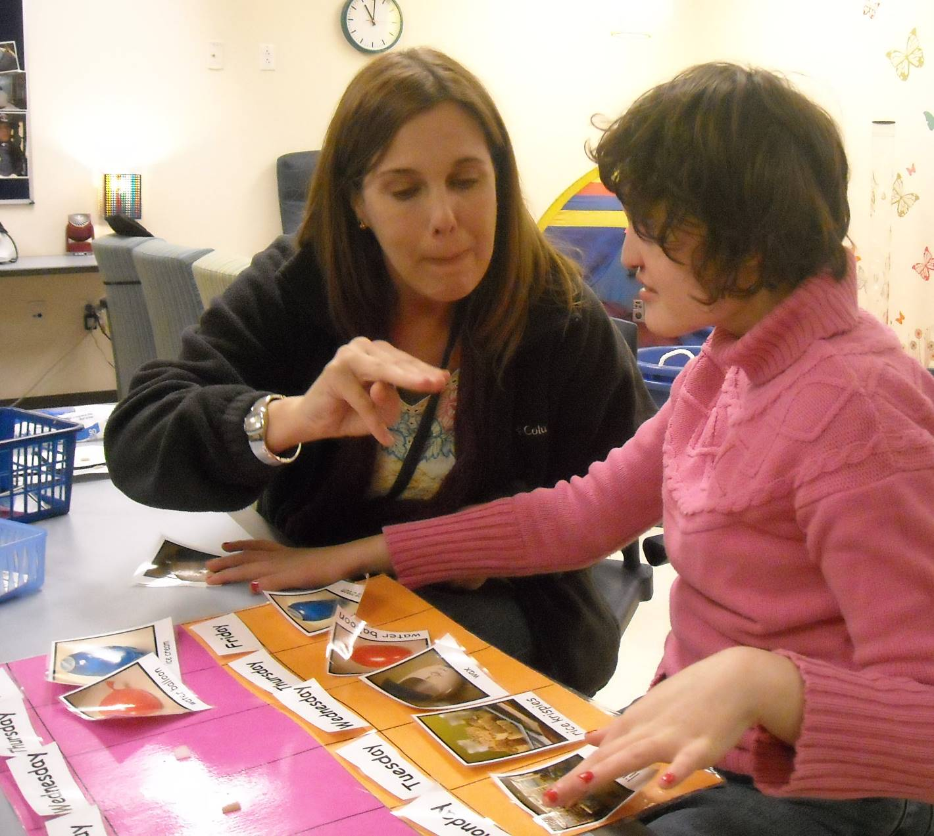
Figure 1 Kersten and her teacher review her daily calendar.

Kersten has a 2 week calendar in my room. There is one picture for each day (representing the daily activity in my class). Prior to coming to my class, her calendar should be placed on the table where she sits, with her finished basket. Kersten is highly independent during calendar. Adult’s should allow her to initiate conversations by pointing to pictures or signing information and encourage conversations by adding signed information or asking questions.

- Kersten will point to the picture representing yesterday.
- Adult point to print label for current day. Model fingerspelling the day slowly. Kersten will imitate. She is also able to fingerspell independently if you point to each letter.
- Adult can initiate a conversation about yesterday by signing something like….”yesterday eat ice cream”. Kersten might imitate or add information in sign language.
- Kersten will remove the picture and place it in the finished basket (small blue basket). Adult sign something like “yes, yesterday eat ice cream finished”.
- Kersten will point to or remove the picture representing “today”. Adult point to the print label for current day. Repeat fingerspelling with Kersten. Conversations can include “today is (insert day of week)”.
- After the “today” conversation, replace today’s picture on the calendar.
- Adult can initiate a conversation about “tomorrow” and the activities for tomorrow or any future activities that Kersten may point to as a request for more information.
- Use the calendar to show any changes or cancellations by drawing with Kersten, labeling the “cancelled” picture in sign, removing it, and replacing it with the drawing. For example holidays and parties.

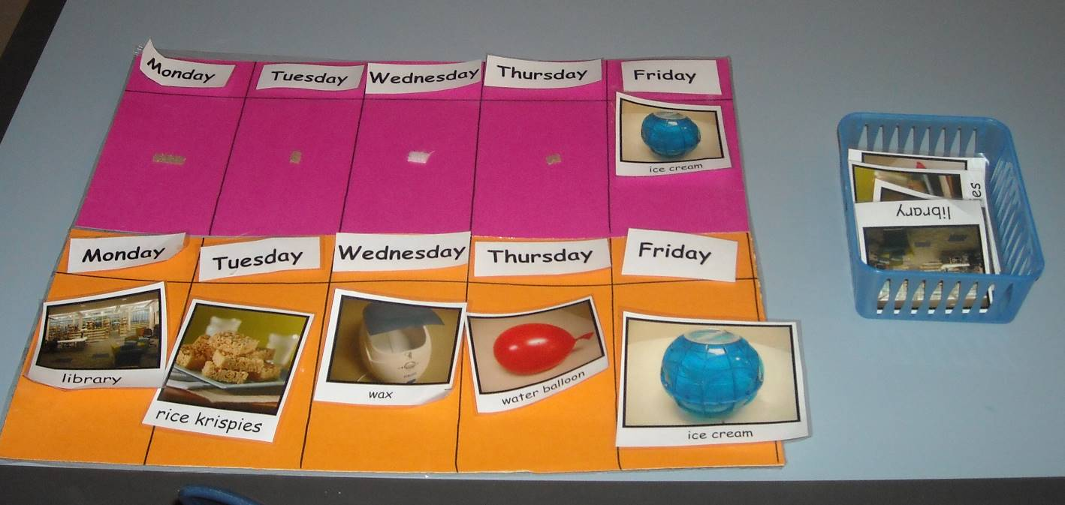
Figure 2 Kersten's picture calendar showing her morning and afternoon activities.

