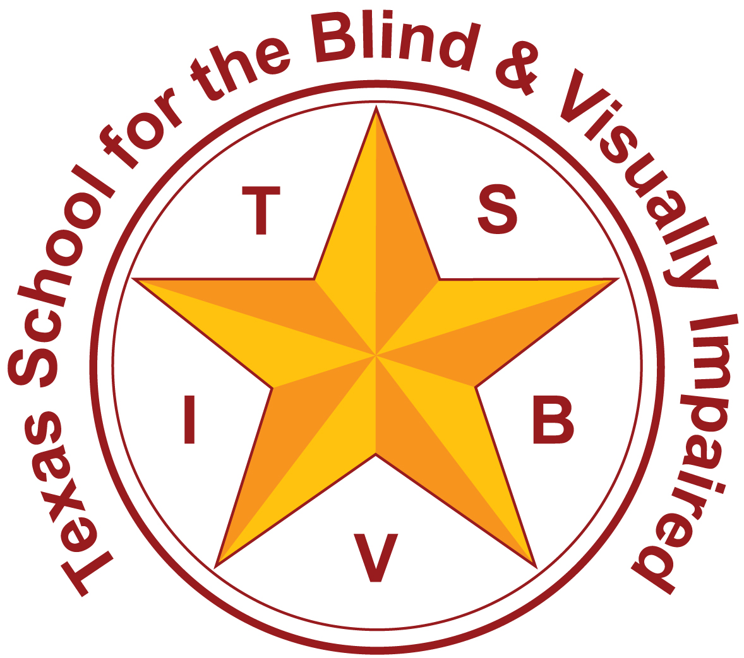 | Texas School for the Blind and Visually Impaired  Outreach Programs  www.tsbvi.edu | 512-454-8631 | 1100 W. 45th St. | Austin, TX 78756

Summary of Deafblind Specific Evaluation Tools

Communication
The Communication Matrix- The Communication Matrix is a free on-line assessment tool created to help families and professionals easily understand the communication status, progress, and unique needs of anyone functioning at the early stages of communication or using forms of communication other than speaking or writing.
https://www.communicationmatrix.org

Access

The Informal Functional Hearing Evaluation (IFHE)- This document is meant to guide the teacher of the deaf and hard of hearing and teacher of the visually impaired in determining the impact of a potential hearing loss on educational functioning for students with visual impairments and multiple disabilities. The IFHE can help provide information about how the child is currently using his or her hearing across a variety of settings. This information should be used to guide the IEP team in developing instructional strategies which specifically address the child’s dual sensory needs. In development by Chris Montgomery and Adam Graves, The Texas Deafblind Project

The Assessment of Deafblind Access to Manual Language Systems (ADAMLS)- by Robbie Blaha and Brad Carlson. A resource for educational teams who are responsible for developing appropriate adaptations and strategies for children who are deafblind and who are candidates for learning manual language systems. The assessment tool should be used for all children with a dual vision and hearing sensory loss (deafblindness) in educational settings that use a form of manual communication. The ADAMLS provides unique and important information in a userfriendly manner to fulfill a need that exists in the field of deafblindness.
https://nationaldb.org/library/page/88

TAPS- An Orientation & Mobility Curriculum for Students with Visual Impairments- By TSBVI. For orientation and mobility specialists who serve students ages 3 to 21 who may also have other impairments. This curriculum includes goals, objectives, and teaching strategies as well as functional mobility tasks, for the following environments: home/living, campus, residential, commercial and public transportation, as well as an ambulatory devices section. The four-part set also includes extensive appendices containing a wide range of O&M related topics and a supplement that details street crossing strategies.
http://www.tsbvi.edu/curriculum-a-publications/3/1042-taps-teaching-age-appropriate-purposeful-skills

Sensory Learning Kit (SLK)- By Millie Smith. Millie Smith, a master teacher specializing in instruction for students with visual impairments who have significant additional disabilities, developed this kit for American Printing House for the Blind. This kit is for use in the development of skills for learners with the most significant challenges. Is an extensive set of sensory items and written materials that help the most significantly challenged learners increase their curiosity and develop specific skills.
https://shop.aph.org/webapp/wcs/stores/servlet/Product_sensory,%20learning,%20kit,%20early,%20childhood,%20sensory,%20development,%20assessments,%20functional,%20assessments,%20multiple,%20disabilities,%20adaptable,%20daily,%20lesson,%20functional,%20assistive,%20technology,%20switches,%20guidebook,%20routines,%20tactile,%20pad,%20tools,%20s_35518303P_10001_11051

Program Based
Functional Scheme Assessment-by Dr. Lillie Nielsen. This functional skill assessment and learning reassessment tool was developed to meet the needs of children and adults who are functioning at a developmental level under 48 months. The purpose of the tool is to create the best possible basis for developing an appropriate learning program each individual learner.
http://www.lilliworks.org/al-items/books-videos/

Infused Skills Assessment- The Basic Skills Infused Skills Assessment is a very effective tool for analyzing the strengths and weaknesses of students with visual impairments who may also have cognitive and behavioral challenges. This assessment begins at a developmentally young, non-verbal skill level, and progresses up to higher cognitive functions, while remaining appropriate for students in life skills programming. The Assessment is contained in TSBVI’s Eval’s Kit.
http://www.tsbvi.edu/publications/1030-evals-evaluating-visually-impaired-students

A Curriculum for Multi-sensory Impaired Children (the MSI Curriculum)- The curriculum addresses the particular learning needs of students with Multi-sensory Impairments including Deafblindness. The curriculum addresses: social relationship and emotional development, communication, conceptual development, sensory response, understanding time and place, orientation, movement and mobility, ownership of learning and responses to routines. The curriculum is available for free download at the following website:
https://www.sense.org.uk/content/msi-curriculum

Child Guided Strategies: The van Dijk Approach to Assessment- by Dr. Jan Van Dijk. This easy-to-use guidebook/manual describes step by step the Child-Guided Strategies: The Van Dijk Approach to Assessment. The manual comes with 2 DVDs. One is a demonstration DVD which shows the assessment of 3 children (baby, a young child, and a teenager) with multiple sensory impairment. The other DVD contains the Guidebook and the electronic forms, which are used in the assessment. The Van Dijk assessment is unique as it follows the lead of the individual learner.
http://www.drjanvandijk.org/component/virtuemart/1/1/manual/child-guided-strategies-the-van-dijk-approach-to-assessment-detail.html?Itemid=0

IEP Quality Indicators for Students with Deafblindness- Developed by the Texas Deafblind Project. This document is designed to help educational teams develop appropriate IEPs for students with deafblindness. The ten content areas that are evaluated include: Etiology, Access to Information, Social Issues, Communication, Calendar System, Behavior, Orientation and Mobility (O&M), Related and Supplemental Services, Transition Planning and A Teaming Process Plan.
http://www.tsbvi.edu/attachments/other/IEP_Indicators.pdf

Determining the Need for an Intervener in Educational Settings- Developed by the Texas Deafblind Project. This document is designed to help the IEP team to determine whether an intervener is an appropriate support for an individual student with deafblindness in a school setting. It is a guideline for discussion about all supports needed to provide the student full access to the educational experience based on: 1) individual student assessment; and 2) consideration of the existing and/or proposed services for the student.
http://www.tsbvi.edu/determining-the-need-for-an-intervener-in-educational-settings-in-texas

The Requisite Concept Evaluation (the RCE)- In Development by the Texas Deafblind Project. A TEKS based academic concept evaluation. The evaluation focuses on concepts taught in science and social studies coursework and helps education teams and families identify conceptual gaps in the student’s understanding of the world. The evaluation targets students with deafblindness being served in academic settings.

Classroom Observational Instrument for Educational Environments Serving Students with Deafblindness- By Ella Taylor, Kathleen Stremel and Nancy Steel. Designed to identify characteristics of model classrooms for students who are deaf-blind. The COI is comprised of three main components: (1) teacher interview; (2) student cumulative folder review; and (3) observation rubric. A final section allows the observer to note any special circumstances or additional information that should be noted about the classroom. A scoring guide is provided so that each individual section can be assessed as well as the total instrument.
http://documents.nationaldb.org/products/coi-2006.pdf

Other resources
Calendars for Students with Multiple impairments including Deafblindness- by Robbie Blaha. This book is written for students who need help structuring and organizing their time and activities. It includes information about: the benefits of calendar systems, calendar programming based on individual students' needs and skills, the continuum of calendars available for expanding students' skills including anticipation calendars, daily calendars, and expanded calendars as well as how to assess and evaluate using a calendar.
http://www.tsbvi.edu/publications/1024-calendars-for-students-with-multiple-impairments-including-deafblindness

Home Talk- A Family Assessment for Children who are Deafblind- HomeTalk is an assessment tool designed for use by parents and care providers of children who are deafblind and who have other disabilities. Its purpose is to help you participate more actively in the planning of your child's educational program. HomeTalk is designed to provide a broad picture of your child's skills, special interests, and personality.
http://documents.nationaldb.org//HomeTalk.pdf

INSITE Developmental Checklist Instructional Manual: Assessment of Developmental Skills for Young Multidisabled Sensory Impaired (MSI) Children- The INSITE manual contains the INSITE developmental checklist. This checklist assesses the areas of gross motor, fine motor, self-help, cognition, social, emotional, communication, vision, auditory, and tactile development. The checklist has illustrated examples based on normal development with adaptations for children who are MSI. The checklist can be used by the parent advisor and parents in the home and results can be used to plan appropriate goals and activities for the family. All behaviors are cross-referenced to activities in specified curricula that can be used to promote skills. The instruction manual contains a description of how to use the INSITE Developmental Checklist and instructions for scoring and reporting. It also contains one complete checklist for children 0-6 years of age.
http://hopepubl.com/proddetail.php?prod=404

